Machine Description | unauthenticated remote code execution via multiple vulnerable WordPress plugins allowing web shell upload and remote inclusion, leading to complete system compromise.
Target IP | 10.18.198.27
Vulnerability Name | Remote file inclusion (RFI) leading to unauthenticated remote code execution (RCE)
Service / Version | TCP / 80 HTTP Apache httpd 2.4.29
CVSS Score and Severity | 9.8 Critical
Attack Vector | CVSS:3.1/AV:N/AC:L/PR:N/UI:N/S:U/C:H/I:H/A:H
Proof Of Concept | STEP 1 – Discover the IP address of the target host  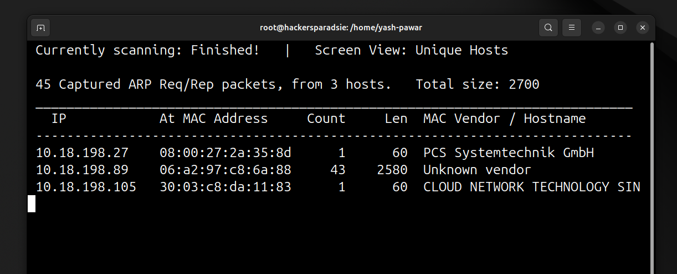  STEP 2 – Scan for Open ports on target using Nmap  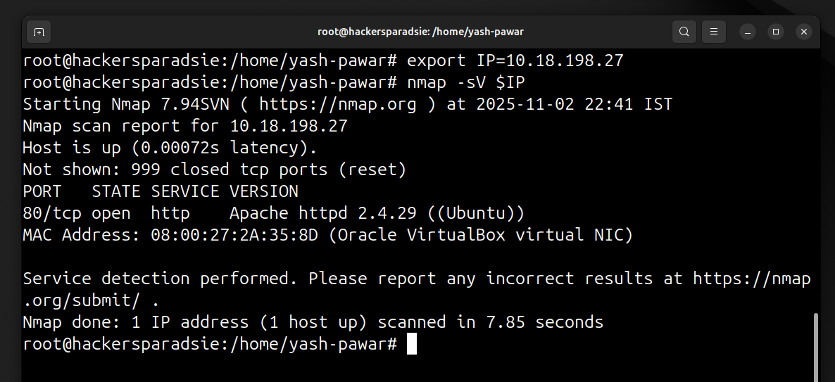  STEP 3 – Lets Enumerate what page is target hosting  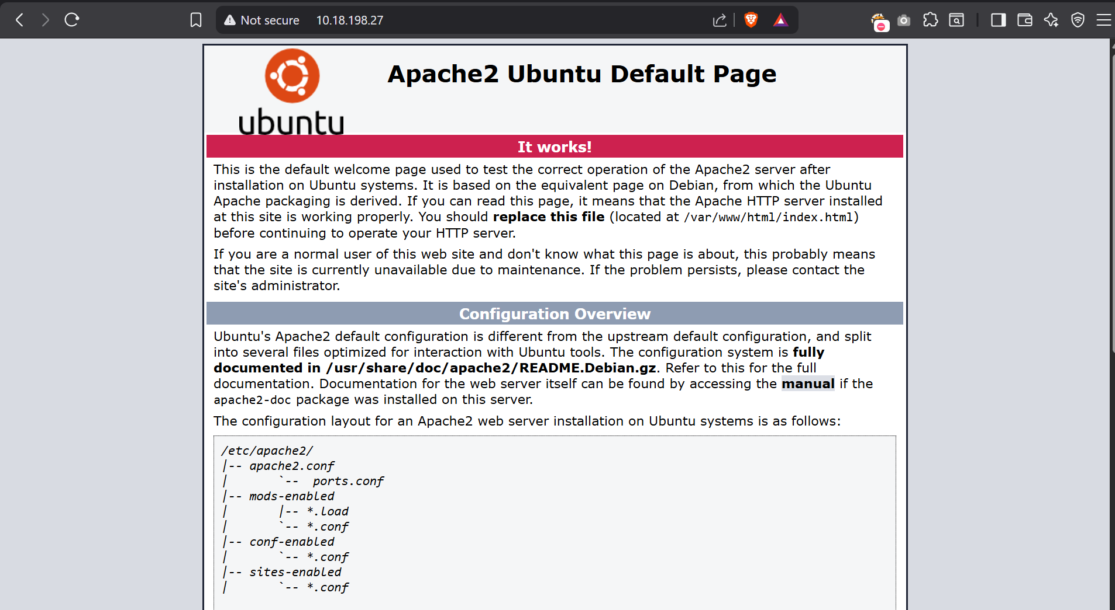  - Looking for available files on web server  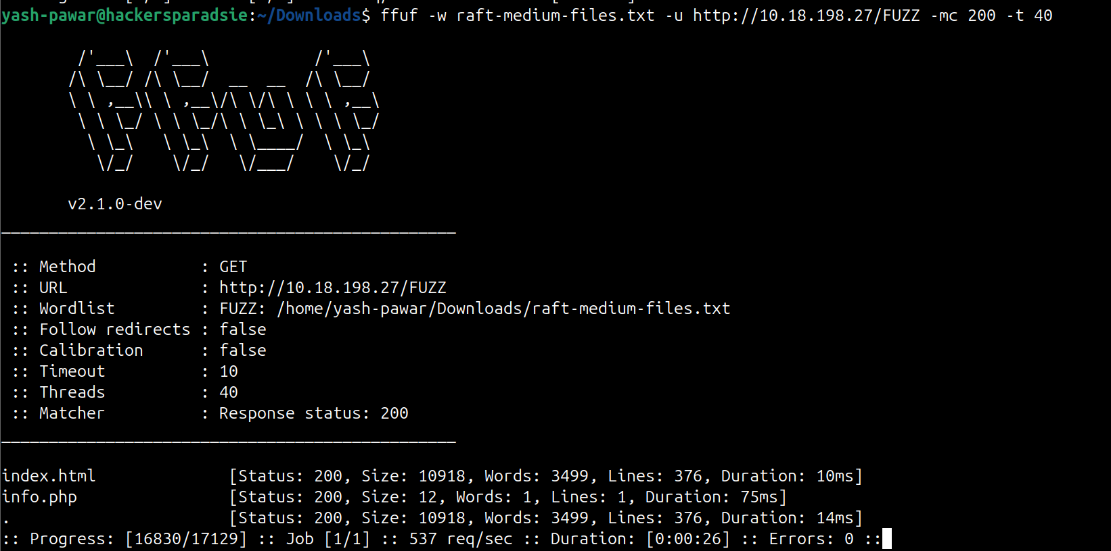  - Looking for the available directories on web server  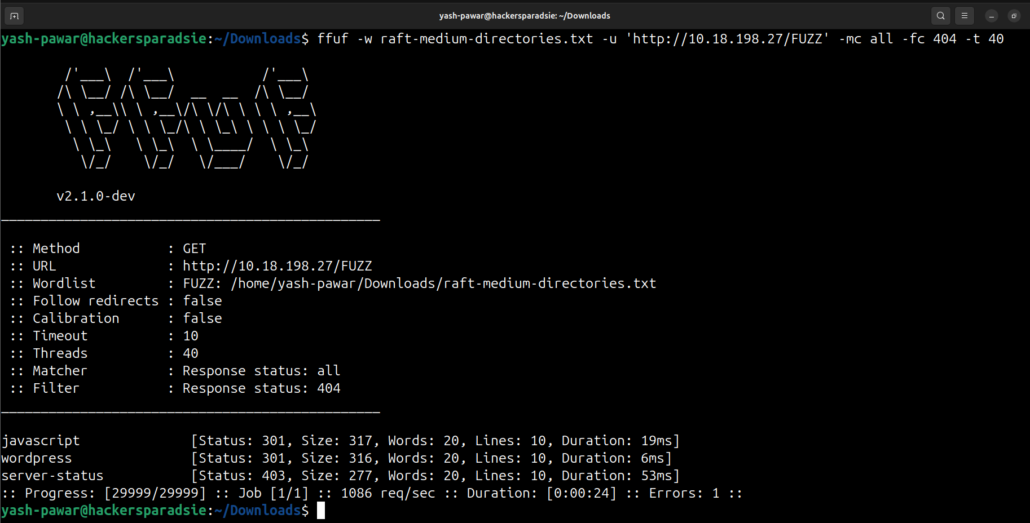  STEP 4 – Lets enumerate on Wordpress directory  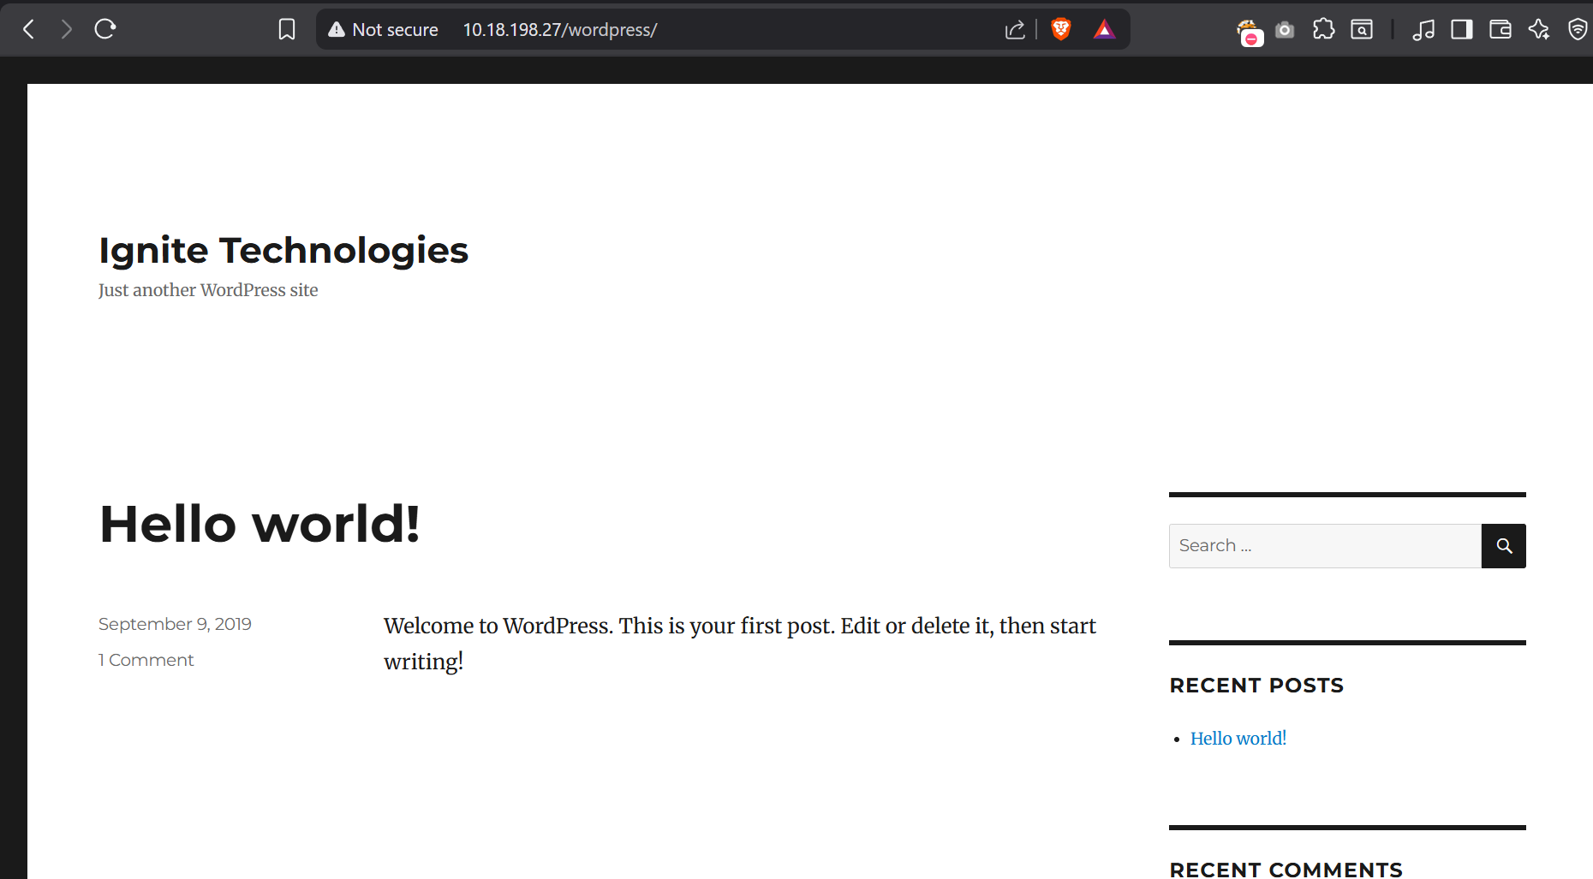  - WpScan to look for outdate plugins  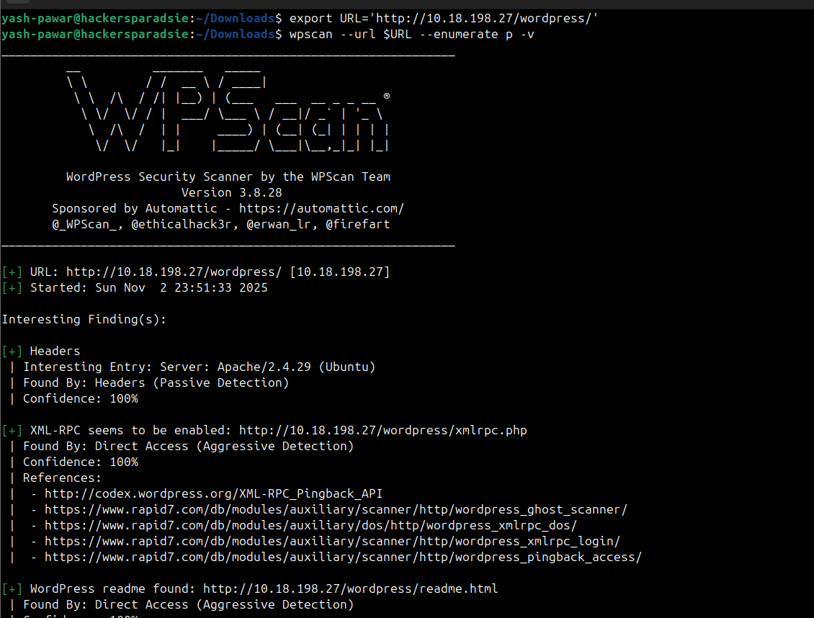  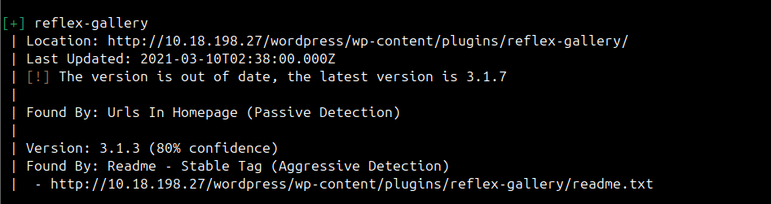  - Found Vulnerable Plugin reflex-gallery lets found the exploit in exploitdb  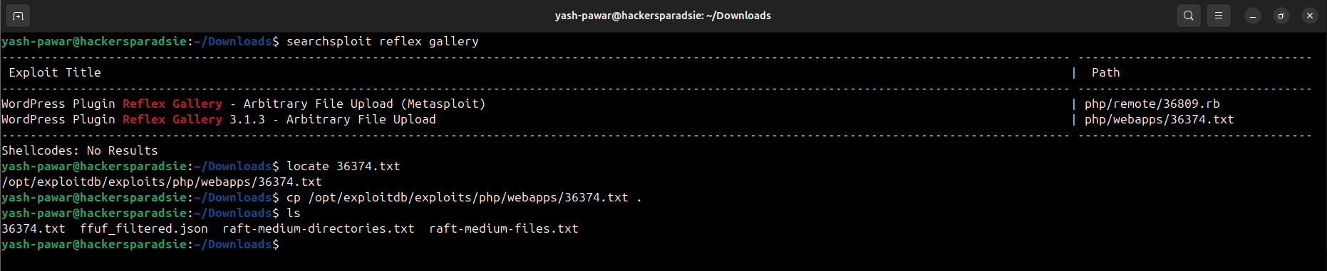  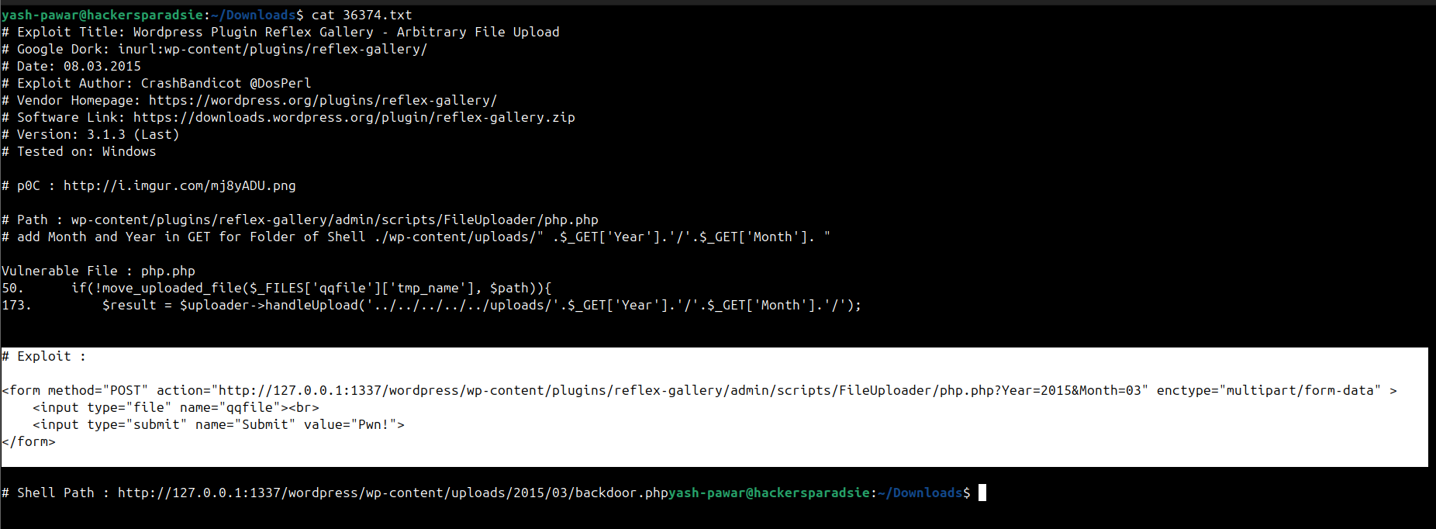  - Got two valid Users ( admin and aarti ) after enumerating using wpscan  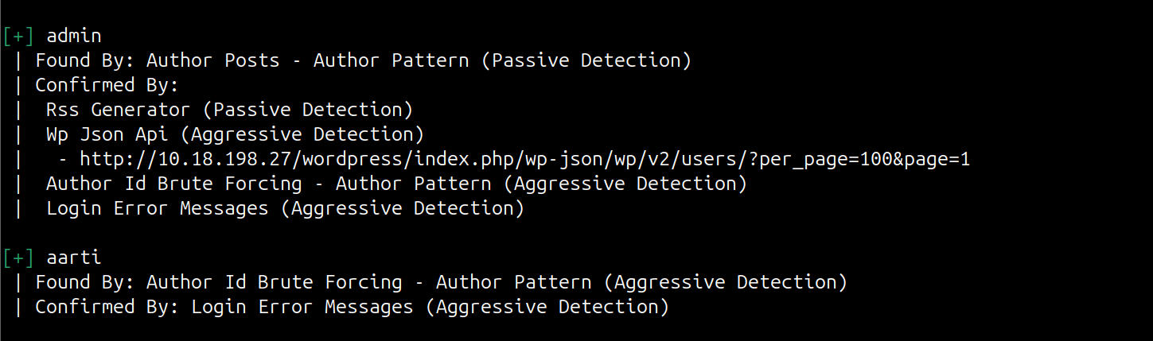  STEP 5 – Lets Build the exploit  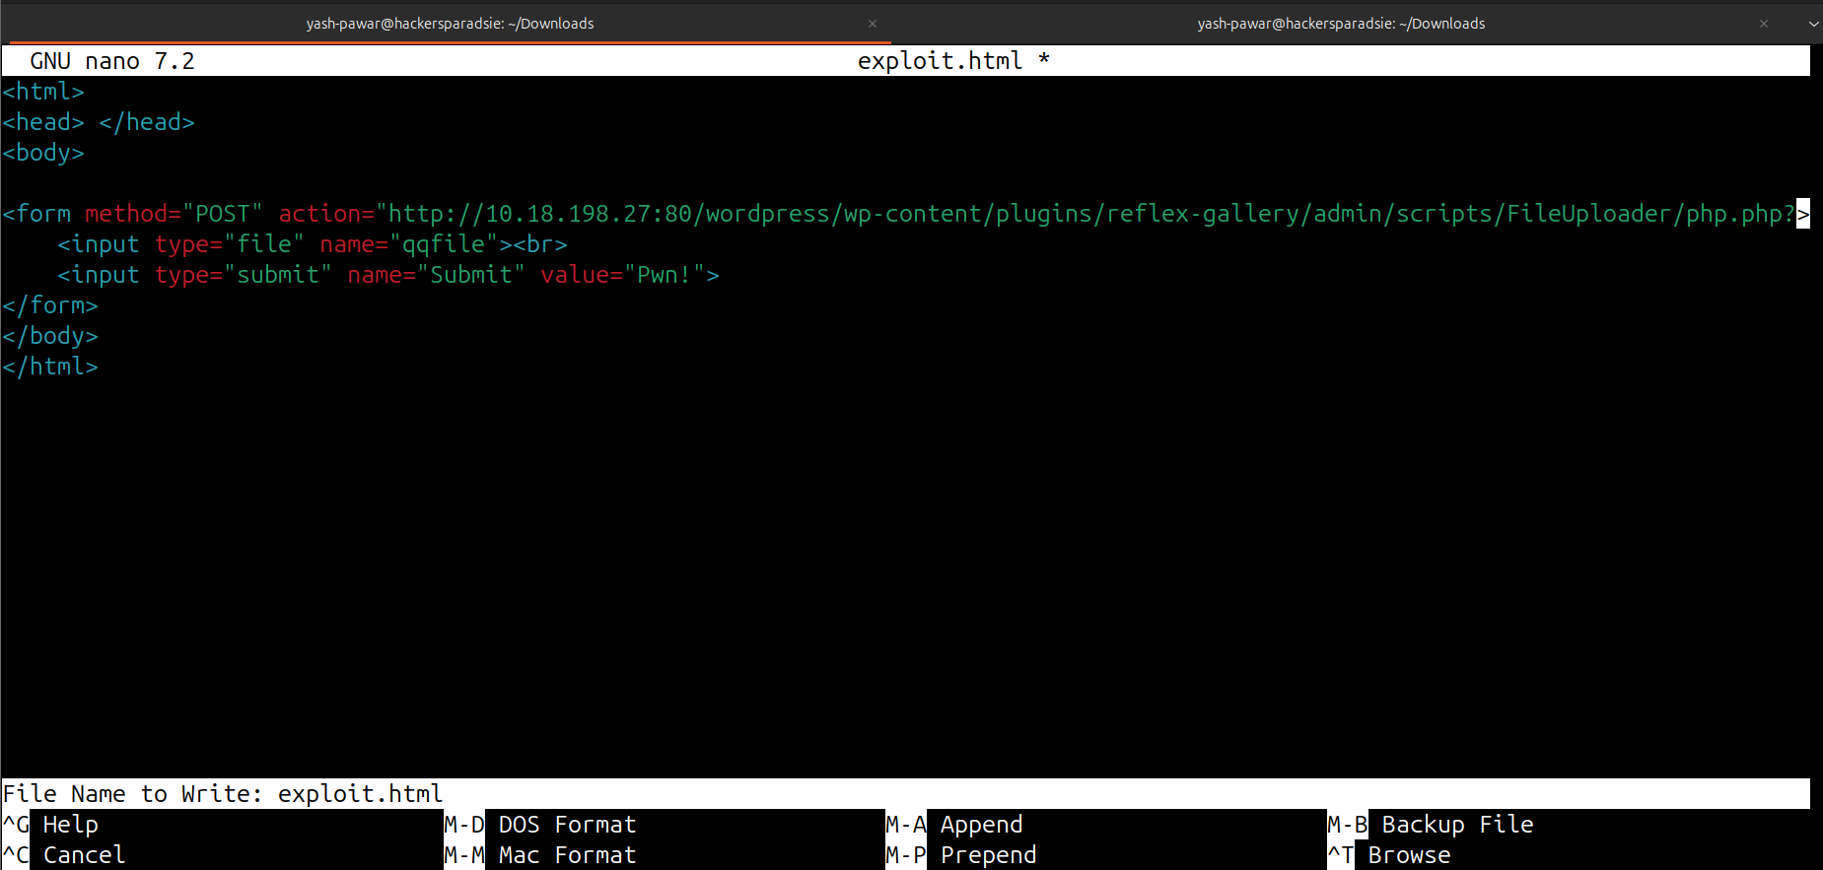  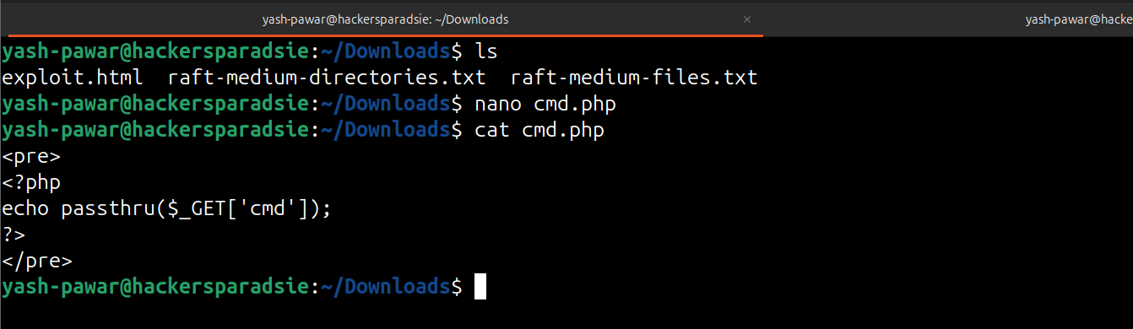  - Lets try to open in exploit.html using firefox  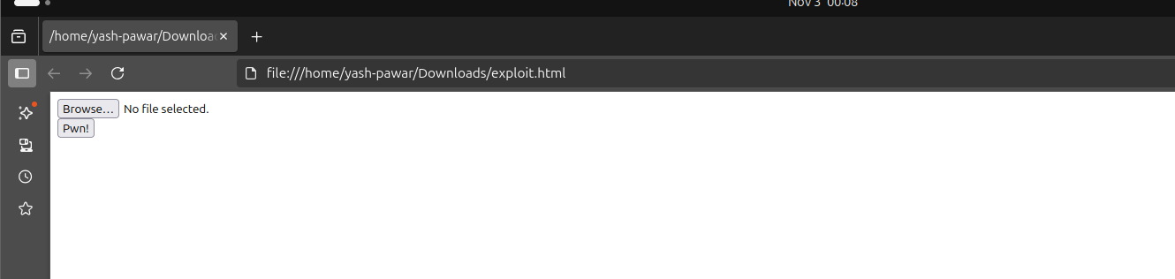  http://10.18.198.27/wordpress/wp-content/plugins/reflex-gallery/admin/scripts/FileUploader/php.php  - Lets upload cmd.php but before uploading visit “http://10.18.198.27/wordpress/wp-content/plugins/reflex-gallery/admin/scripts/FileUploader/php.php?Year=2015&Month”  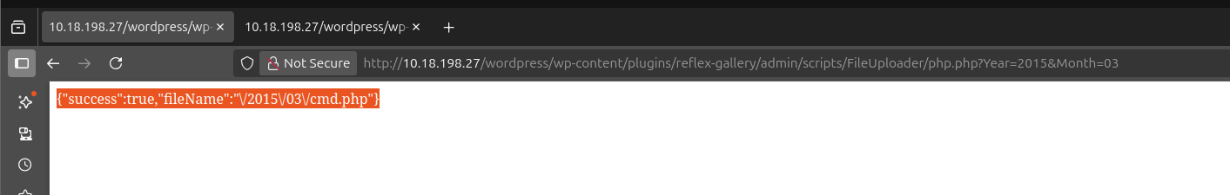  - We uploaded successful lets visit “/wp-content/uploads/2015/03/” we can see our php shell  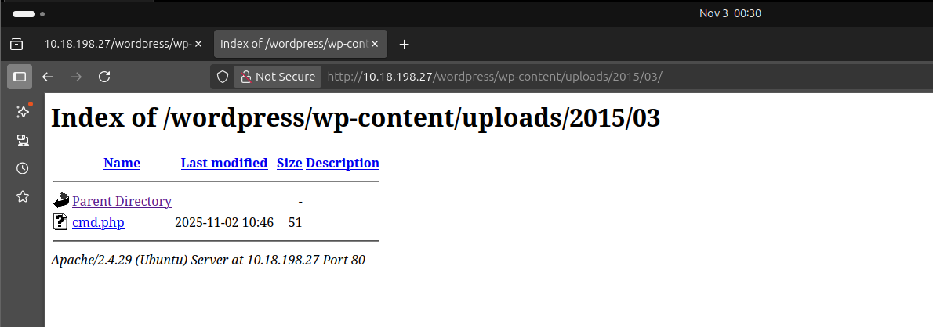  - We got shell here  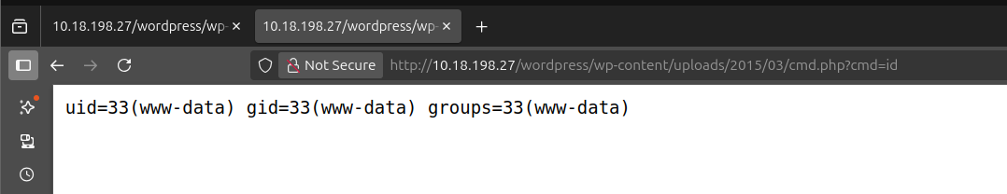  STEP 5 – Lets make interactive shell  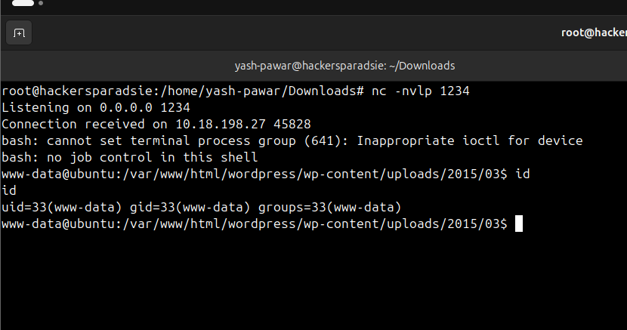  STEP 6 - Privilege Escalation by insecure permissions  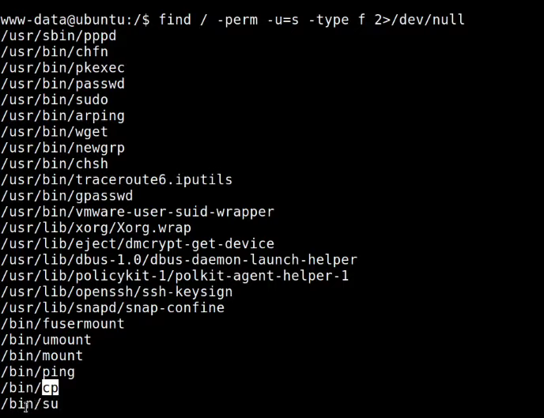  - As we can see we can use /bin/cp as root so lets create new passwd file and new user in it and replace it with original one so we are exploiting improper permissions to binaries and using them to implant new user  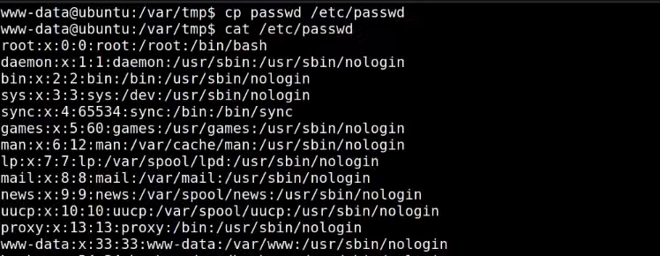  - We got Root and here is the root flag which is proof.txt  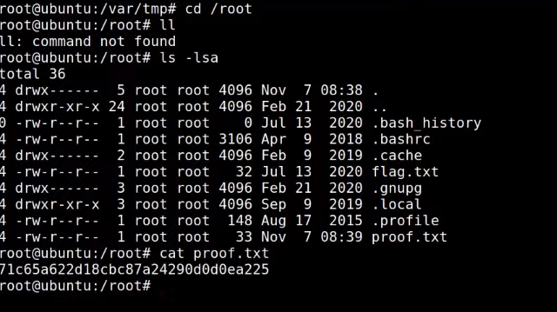
Impact | - remote shell gives attacker full control of web user context.  - sensitive files and database credentials can be exfiltrated.  - attacker can pivot or escalate via SUID binaries or weak configs.  - service integrity and availability can be destroyed or disrupted.
Remediation | - remove or restrict vulnerable plugins and keep WordPress and plugins patched.  - harden upload handling : validate file types, enforce server side checks, store uploads outside webroot.  - apply least privilege to web processes, remove unnecessary SUID bits, and use app isolation.  - monitor web logs, deploy WAF rules for known plugin exploits, and run periodic plugin vulnerability scans.
Reference | https://www.vulnhub.com/entry/ha-wordy%2C363/

